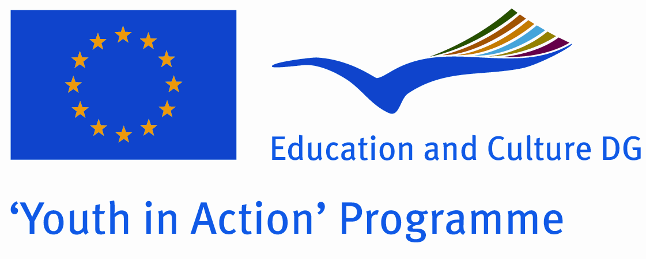 | Expression of Interest  Action 2 - European Voluntary Service  Version valid as of 1 January 2008  Annex 1 – Sending Organisation

Sending Organisation
This part has to be filled in only if the applicant requests to be accredited as Sending Organisation. The points below are intended to serve as a guide for the description of activities foreseen by the Sending Organisations.
If more space is needed, please extend boxes.
Preparation of volunteer:
Please describe how the preparation process of volunteer will be organized before his/her departure to EVS project as well as the sending procedure.
The Centre of Leisure Time in Gelnica working as a sending organisation for EVS volunteers will first of all inform a volunteer interested in the EVS project with all principles of EVS projects, financing, rules and responsibilities of a volunteer and his/her sending and hosting organisation. We will help to choose suitable project and a hosting organisation abroad. In the preparation process we will help with the English, with writing a volunteer´s profile, requesting for a financial support and with the communication with the hosting organisation through internet, phone or by mail.
Due to the choosen country we can find or help to find the information about the country, its culture, language, currency, basic law, infrastructure in the country and the chosen town, healthcare, eating culture. We will help with searching for materials, we will provide free internet for this purpose as well. So that the volunteer can present our country abroad we will help him/her to collect or buy materials about Slovakia, our region and about our town.
In the case the volunteer will go for a specialized position such as healthcare, work with disabled people or work with children we will provide few weeks of education or training in the same centres in our region (Centre of Leisure time, schools, Department for disabled people). In the case of another position we will try to find possibility of training at the same position close to our region. If there are some necessary materials to prepare or working tools to take with, we can help to prepare or to buy them. Another education provided by our organisation is a language course of a target country.
For the safety of a volunteer, we will prepare him/her for his journey by bus, by train or for a flight. We will give him/her basic telephone numbers for Slovak ambasy in the country or in the neighbour countries, for police and ambulance, insurance company where he/she will be insured (insurance also supplied by us through AXA).

Recruitment process:
Please describe how you ensure an open and transparent recruitment process as well as promotion of Youth in Action programme – European Voluntary Service.
We will host a volunteer first, and therefore we will promote him/her and their work among young people from the region in secondary schools. We will present EVS projects through him/her to the Grammar school in Gelnica, to Secondary schools in Prakovce or Krompachy or to the rest of the young who do not study any more on public meetings organized by the Centre of Leisure Time in Gelnica or in surrounded villages. A good example (a foreign volunteer working in our Centre of Leisure Time) together with explanation of all facts about the EVS will be a good promotion for the EVS projects for the young in our region. All the young will properly see what does the EVS mean, they will learn about its priorities, themes or financing of the project. We will explain what are the rules, responsibilities and how does the volunteer feel abroad, what does he learn by traveling abroad. Finally, we will offer the EVS to the young, providing some actual vacancies in EVS projects. As a sending organisation we will help them to find a suitable project and hosting organisation abroad.
All activities of the volunteer we will host, will be published through Gelnica newspaper, they will be published together with photos and comments on our internet website as well. As our volunteers will assist on all public events in the town, he/she will meet the young and will personaly present the EVS. The EVS project will be shown on public and we will recruit the young who will be impressed by it and who want to go for the EVS abroad. This way we can ensure an open and transparent recruitment process for all young people interested in EVS and also for those who do not know it yet.

Reintegration of volunteer (s) into the home community after return from EVS project:
What kind of support will you provide to volunteer(s) to help them reintegrate into their home community after return.

After volunteer´s return, after he/she gained experiences in the area of children education or leisure time activities we can offer him/her part-time job in the case he/she will be able to lead a club with children or the young. This always depends on the financial situation of the Centre of Leisure Time. We can give him/her the chance to apply experiences from abroad in our home community. When he/she will be experienced in another type of activity, we can help to look for a job or organizations that need this kind of experience.
We will stay in contact with a volunteer. Heúshe can further help with the promotion of the EVS as a Youth worker. He/she will have actual materials, photos and living experiences from abroad and from the EVS project. He/she can help us in the following recruitment process of other volunteers. He/she can help other volunteers with the preparation of their EVS, collecting materials, writing and communicating in English or with preventing possible problems.
There are documents to be filled in and the project evaluation to be written after returning the volunteer to the home community. We will help the volunteer to fill in these documents and to send them to his/her host organization. Together we will apply for the Youthpass that will help to prove volunteer´s experiences gained through the EVS in the future recruitment process of a volunteer applying for any job.

